- Pending PR should load descending order
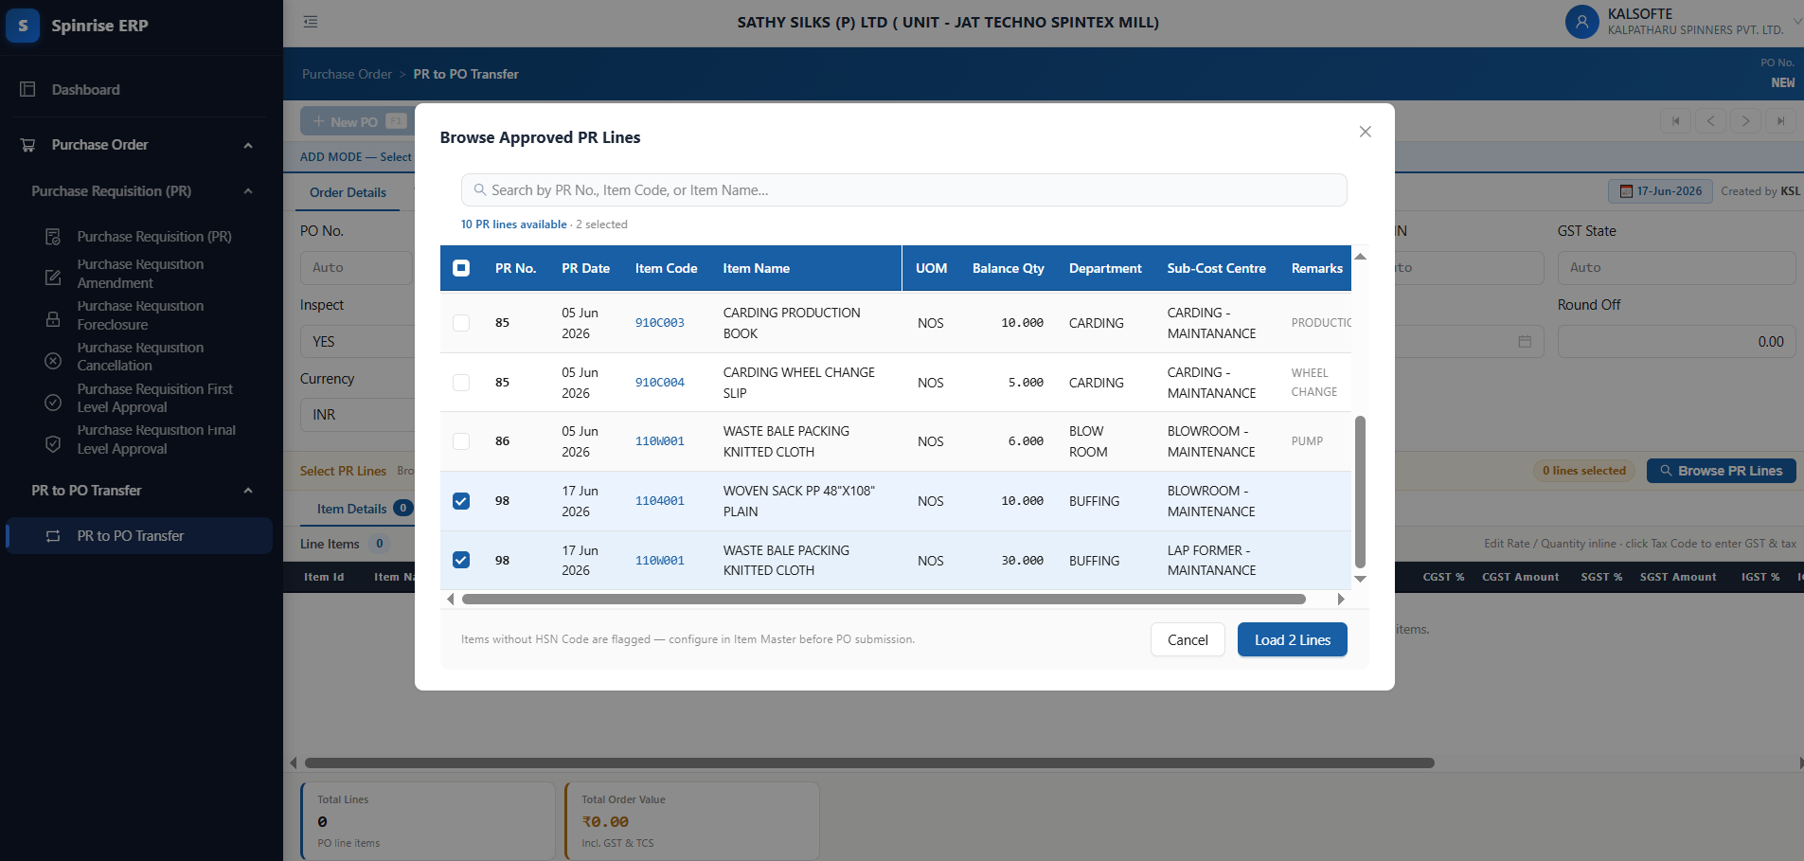

- after PR selected cursor focus move to Order type
- Supplier name include with add1 +add2 + city
  - 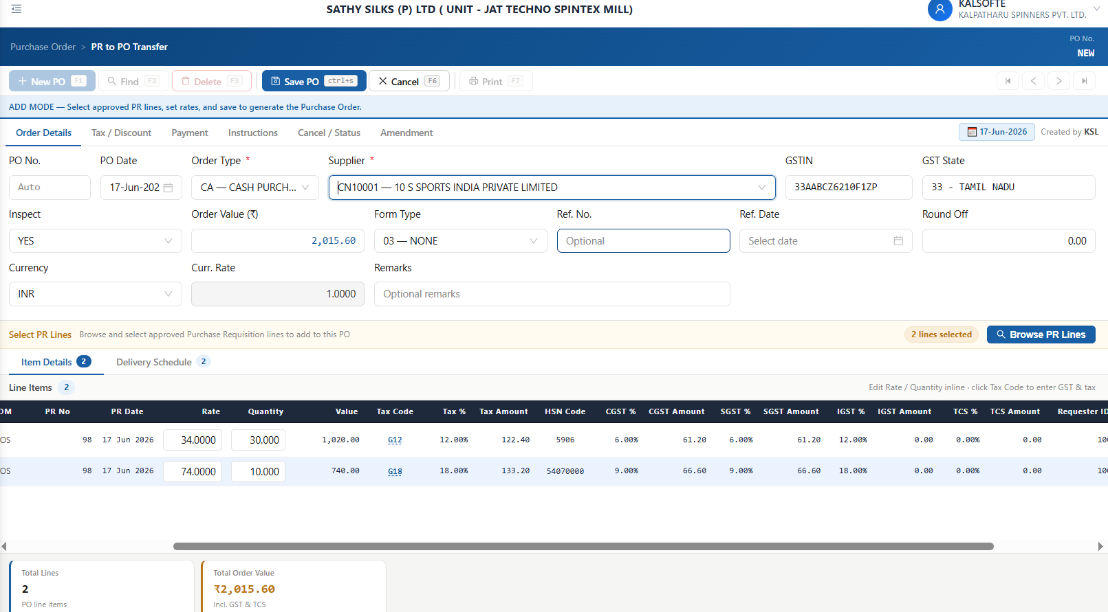

4. Order value (Rs) should place after roud off.
5. Order Value in billing currency option required.
6. after selected Supplier is home state IGST % not cleared but igst amount removed.
7. Item grid need to visible multiple item
8. in item grid ,Display discount % and amount,Freight % and Amount, Packing % and amount Insurance % Amount ,Other amount and Landing Cost.
Landed Cost - Display after TCS Amount and other amounts are displayed before GST
9. When entering the freight Amount freight % calculated automatically
10. Discount ,Freight and other amounts - Before and after change GST amount not changed.
- Additional Tax not required
- Unable to enter Discount ,freight amount and other amount directly in Tax Window.
13 if entered in %in Discount or freight amount are calcluted but GST amount not changed -
14. Rate and Quantity edit option need in GST Window

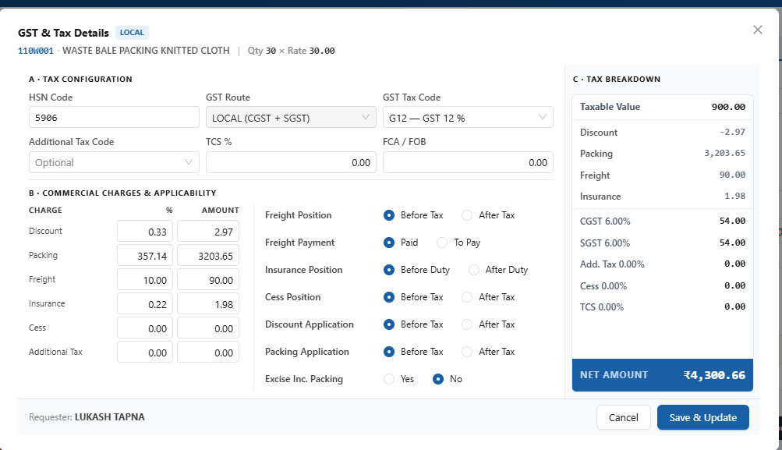

12. Delivery schedule :
A.Schdeule Quantity allowed to enter more than PO quantity but not allowed to save.
B. Slot to be remove
C. Multiple delivery added for the PR items - do not allow to select same date more than one schedule
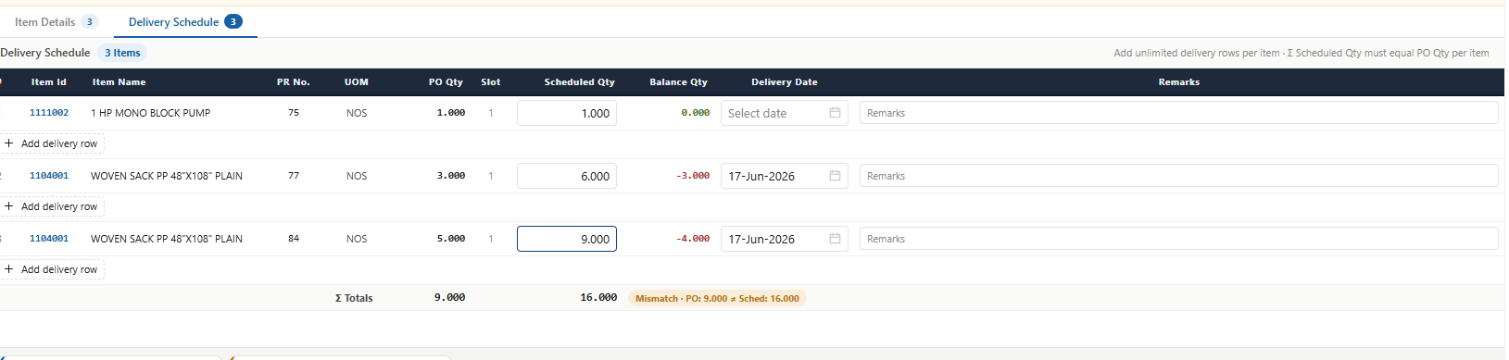

- PO date -do not allow future date and do not allow before last PO date.
- If Reference date selected it should less than or euqal to PO date.
- UI/UX should same like PR form.
- Carrier - By default showing Courier. In addition it should clear.
- Created by should show name instead of Code.
- Discount Amount should show actual Amount ‘-’ sign not required.

PR to PO Process completed but some finetunning correction required.

